Project Design Phase-I Problem – Solution Fit

|  |  |
| --- | --- |
| Date | 9 October 2022 |
| Team ID | PNT2022TMID51074 |
| Project Name | AI based discourse for Banking Industry |
| Maximum Marks | 2 Marks |

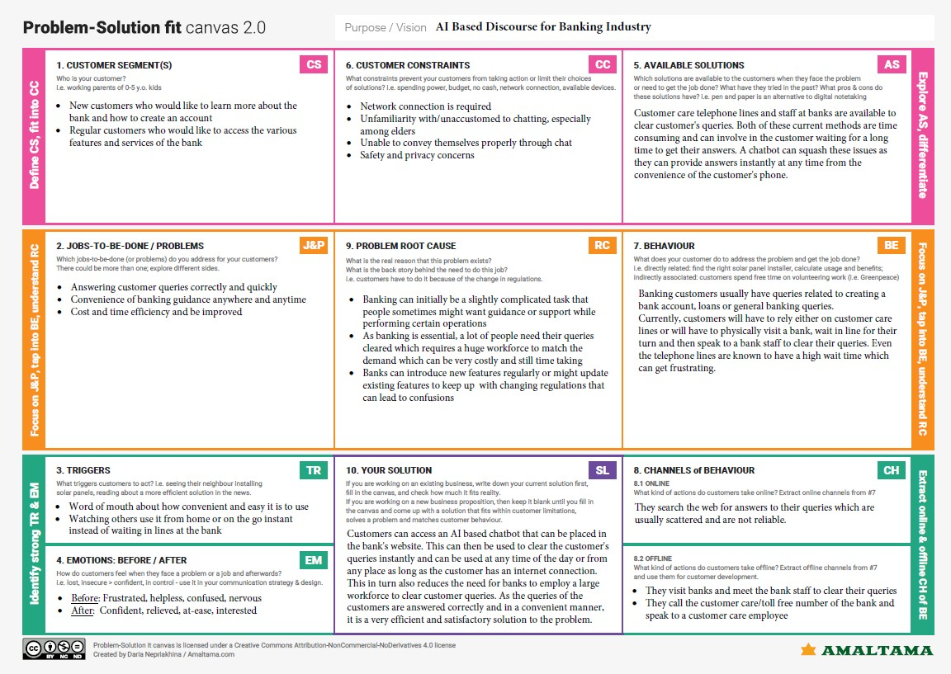**Problem-Solution Fit Canvas:**